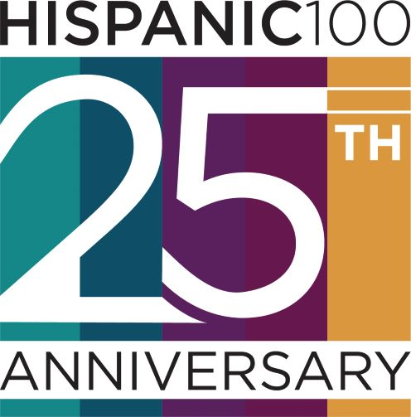
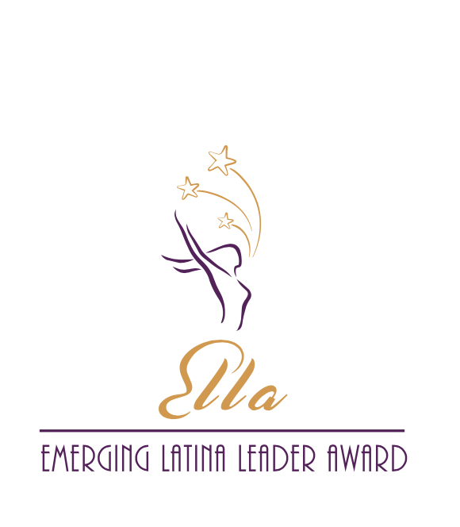

2021 NOMINATION FORM
Emerging Latina Leader Award (ELLA)

Send completed Nomination Form to connect@dfwhispanic100.org

THE HISPANIC 100, a group of professional Latinas in leadership roles, is seeking nominations for the Annual Emerging Latina Leader Award (ELLA). The award is presented to a Dallas/Fort Worth metro-area woman making an impact on Latina women and girls through their personal engagement and leadership in their community, profession and/or industry. To be considered, nominee must be a Latina professional with a minimum of 5 years of service/impact. The nominee’s impact should be measurable, meaningful, and substantive for the benefit of others within the community.

The deadline for nomination submission is 5:00 pm on Wednesday, June 30, 2021. Our honoree will be recognized at the Hispanic 100 Latina Living Legend / ELLA Awards Program on Thursday, September 30, 2021.

Nomination Form:

Nominator Information
Name
Address
Phone/Cell Phone
E-mail
Relationship to the Nominee

Nominee Information*
Name
Home Address
Phone/Cell Phone
Personal E-mail
Social Media Handle(s)
Employer
Work Address
Work E-mail
Position
Years in Position

Please submit a bio, high-resolution headshot of the nominee, and at least one (1) letter of recommendation, with the completed Nomination Form to connect@dfwhispanic100.org.

• Maximum number of pages: Five pages including cover sheet, 12-point font
• Incomplete nominations and those received after the deadline will not be considered
• Nomination Form and attachments will not be returned

* Please note award recipient must provide photo assets as requested and be available for a promotional photo/video shoot.

References
Please provide two (2) references that may be contacted to verify the scope and extent of the nominee’s contributions. References cannot include the nominee or relatives of the nominee.
Name:
Affiliation:
Address:
Phone:
E-mail:
Name:
Affiliation:
Address:
Phone:
E-mail:

Impact Statement (300-word maximum)
Share the impact the nominee has made for Latina women and/or girls through personal, professional or community engagement. Highlight measurable results or examples through volunteerism, philanthropy, fundraising, mentorship, sponsorship and/or other efforts.
Leadership Statement (300-word maximum)
Share how the nominee has taken a leadership role through personal, professional or community engagement to make an impact for Latina women and/or girls at the local, state and/or national level.

Nomination Statement (300-word maximum)
Describe why you believe the nominee is an Emerging Latina Leader on the path to becoming a Latina Living Legend.

Additional Information
Provide any additional considerations, awards, recognition, Board service or other information you would like to be considered with the application. You may also attach a copy of the nominee’s bio and/or resume.

